Exhibit B: Washington EHBs on the 2026 Plans & Benefits Template

Purpose
These instructions explain how to correctly populate the Essential Health Benefit (EHB) information of your Plans and Benefits template (PBT) for Washington State. Note that the changes included in these instructions are in addition to the changes made by the Washington State EHB Add-In file provided by the Center for Consumer Information and Insurance Oversight (CCIIO). Washington State does not use the “PY2026 Standardized Plan Options Add-in” file.

Please go to the CCIIO Qualified Health Plan Application Instructions, Templates and Materials page (https://www.qhpcertification.cms.gov/QHP/applicationmaterials) for the 2026 Qualified Health Plan templates and Add-In file.

Background Information
The Plans & Benefits template (PBT) is an Excel workbook made up of at least two worksheets. One is labeled “Benefits Package [Number]”, and the other is labeled “Cost Share Variances [Number]”. The Benefits Package worksheet is separated into three sections. The first section is the identification of the issuer and market to which the Binder applies (labeled “Binder Identification” in the screen shot below). The next section is where the issuer identifies the plans and their attributes (labeled “Plan Identification and Attributes” in the screen shot below). These sections are followed by the third section that begins with the heading “Benefit Information.” (Labeled “EHB Information” in the screen shot below.) This third section includes the information about coverage of the Essential Health Benefits (“EHBs”) required in the applicable state.

CCIIO provides an Add-In file that helps users complete the EHB Information section of the PBT. The Add-In file will populate the EHB Information automatically once the “Issuer State” (WA) and applicable “Market Coverage” or “Dental Only Plan” fields are selected in the “Binder Identification” portion of the template (red circle). Although most of this information is correct, some changes are required. These instructions explain how to make changes necessary to correct the information that is automatically populated, and to customize it based on your plan design. You may cover more than the EHB benchmark plan minimum. Your PBT must reflect the actual covered benefits.
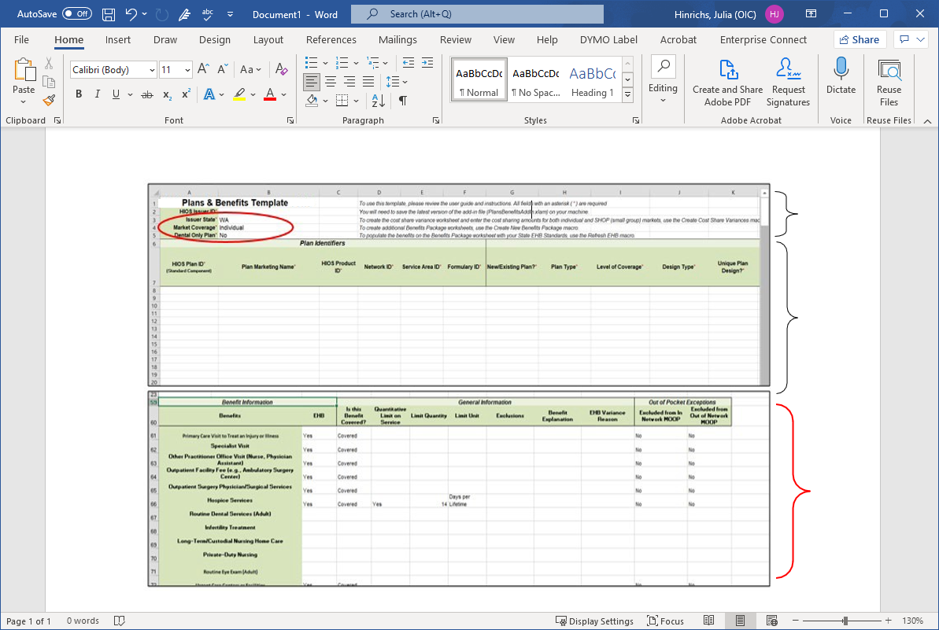
EHB Information
Plan Identification
and Attributes
Binder
Identification

How to use these instructions
There are two sections to these instructions: these narrative instructions (Exhibit B) and a visual map of corrections (Exhibit C, Visual Map of PBT with Washington EHBs). Exhibit B and Exhibit C are designed to be used together.

Exhibit C - Visual map
The visual map is an Excel workbook with 3 sheets.

The sheet labeled “Cascade & Cascade Select ONLY” shows changes to be made in the Cascade Standardized and Cascade Select Public Option medical plan’s PBTs, and the “Individual-Small Group Medical” shows the changes to be made for both the medical individual and small group market PBTs.

The sheet labeled “SAPDental” shows the changes to be made in stand-alone pediatric dental PBTs for both the individual and small group markets.

Each sheet contains two views: how the EHB information is populated by the Washington State PBT Add-In file, and how the final EHB information must look in each Benefits Package worksheet of the PBT when submitted to the OIC. Note that the visual map includes some changes that will be made depending on the benefits covered in the specific plan shown on the PBT. See the legend below.

Legend:
Green: Changes specific to the Cascade Standardized and Cascade Select Public Option plans. For the Benefits Package worksheet to be accurate, Silver and Bronze Cascade Standardized and Cascade Select Public Option plans must be listed under a separate worksheet from the Cascade Standardized and Cascade Select Public Option Gold plans. Note that some required and optional changes listed below also apply to the “Cascade & Cascade Select ONLY” PBT worksheet.
Red: Required Changes
Gold: Optional Changes (whether a change is necessary depends on if and how the benefit is covered)

Plan & Benefits Template (PBT) Instructions

Note: See the Washington State SERFF Health and Disability Binder Filing General Instructions for additional information on when information should be added to the “Benefit Explanation” field on the PBT Benefits Package worksheet.

Columns: You will be working in the following columns in the PBT:

Column Letter | Column Heading
D | Is this Benefit Covered?
E | Quantitative Limit on Service
F | Limit Quantity
G | Limit Unit
I | Benefit Explanation
J | EHB Variance Reason

IMPORTANT: EHB Variance Reason’s (Column J) “Substituted,” “Substantially Equal,” “Using Alternate Benchmark,” “Not EHB – Defrayed to Issuer,” and “Not EHB – Defrayed to Enrollee” are not acceptable variance reasons in Washington State.

Cascade Standardized and Cascade Select Public Option

- Cascade Standardized and Cascade Select Public Option plans - For the Benefits Package worksheet to be accurate, Silver and Bronze Cascade Standardized and Cascade Select Public Option plans must be listed under a separate worksheet from the Cascade Standardized and Cascade Select Public Option Gold plans.
- Benefits Package worksheet:
  - The WAHBE 2026 Standard Plan Designs for the Silver and Bronze plans identifies certain services eligible for the first two visits at $1 copay, after which stated cost-sharing applies.
    - For specific benefits (Primary Care Visits to Treat an Injury or Illness, Other Practitioner Office Visits (Nurse, Physician Assistant), Mental/Behavioral Health Outpatient Services, and Substance Abuse Disorder Outpatient Services), you must populate Column I (Benefit Explanation) with the following language: “First two visits covered at $1 copay, then regular copay amounts apply. This two-visit allowance is shared with [Primary Care Visits to Treat an Injury or Illness] [Other Practitioner Office Visit (Nurse, Physician Assistant)] [Mental/Behavioral Health Outpatient Services] [Substance Abuse Disorder Outpatient Services].”
- Virtual care (telehealth)-For specific benefits (Primary Care Visits to Treat an Injury or Illness, Other Practitioner Office Visits (Nurse, Physician Assistant), Mental/Behavioral Health Outpatient Services, and Substance Abuse Disorder Outpatient Services) you must add the following information to Column I (Benefit Explanation): any differences in telehealth cost sharing from in-person services, applicable limitations, virtual provider referral requirements, or other virtual care (telehealth)-specific benefit characteristics. Also explain where this information can be found in the certificate and schedule of benefits.
- Mental/Behavioral Health Outpatient Services and Substance Abuse Disorder Outpatient Services – you must add the following information to Column I (Benefit Explanation): when cost sharing differs between office visits and outpatient services (non-office visits) provide details regarding cost sharing for the less common setting and refer to where more information can be found. Alternatively, if cost sharing does not differ between office visits and other outpatient services (non-office visits), still explain this fact in the Benefits Explanation field (for example, "There are no differences in cost sharing between office visits and other outpatient services (non-office visits)").
  - Emergency Room Services - add the following language to Column I (Benefit Explanation): “The cost share for Emergency Care Services covers facility fee and professional services.”
  - Inpatient Physician and Surgical Services – add the following language to Column I (Benefit Explanation): “The cost share for all Inpatient Services is a bundled fee that covers the facility fee and professional services.”
- Cost Share Variances worksheet: Populate the two visits under the “Begin Primary Care Cost-Sharing After a Set Number of Visits?” column under the “AV Calculator Additional Benefit Design section.

Primary Care Visits to Treat an Injury or Illness, Other Practitioner Office Visits (Nurse, Physician Assistant), Mental/Behavioral Health Outpatient Services, and Substance Abuse Disorder Outpatient Services
- You must populate Column I (Benefit Explanation) with an explanation of any differences in telehealth cost sharing from in-person services, applicable limitations, virtual provider referral requirements, or other virtual care (telehealth)-specific benefit characteristics. Also explain where this information can be found in the certificate and schedule of benefits.

Cosmetic Surgery
- You must populate Column D with “Covered” and populate Column J with “Additional EHB Benefit”.
- You must populate Column I (Benefit Explanation) with: “Covers cosmetic surgery when medically necessary.”

Mental/Behavioral Health Outpatient Services and Substance Abuse Disorder Outpatient Services
- You must populate Column I (Benefit Explanation) when cost sharing differs between office visits and outpatient services (non-office visits) with details regarding cost sharing for the less common setting and refer to where more information can be found. Alternatively, if cost sharing does not differ between office visits and other outpatient services (non-office visits), still explain this in the Benefit Explanation field (for example, "There are no differences in cost sharing between office visits and other outpatient services (non-office visits)").

Generic Drugs, Preferred Brand Drugs, Non-Preferred Brand Drugs, Specialty Drugs, and Habilitation Services
- You must populate Column J with “Other Law/Regulation”.

Routine Foot Care
Routine Foot Care is covered under the state benchmark plan.
- You must populate Column D with “Covered” and populate Column J with “Additional EHB Benefit”.

Gender Affirming Care
Gender Affirming Care is required under 42 USC §18116, RCW 48.30.300, and RCW 49.60.040(26) and (27).
- You first must add Gender Affirming Care to the Benefits Information using the “Add Benefit” button provided in the PBT Add-In file.
- You must populate Column D with “Covered” and populate Column J with “Other Law/Regulation”.
- You must populate Column I (Benefit Explanation) with “Gender Affirming Care includes health care services prescribed to treat any condition related to the individual's gender identity and may include primary care visits, specialty care, outpatient mental health services, prescription drug benefits, and surgical services.”

Note that cost share values (copay and coinsurance) in the Cost Share Variances tab must be based on the most common cost share expected for the gender affirming care benefit.

Diabetes Care Management
- You first must add Diabetes Care Management to the Benefits Information using the “Add Benefit” button provided in the PBT Add-In file.
- Then you must populate Column D with “Covered” and populate Column J with “Additional EHB Benefit”.

Inherited Metabolic Disorder – PKU
- You first must add Inherited Metabolic Disorder - PKU to the Benefits Information using the “Add Benefit” button provided in the PBT Add-In file.
- Then you must populate Column D with “Covered” and populate Column J with “Additional EHB Benefit”.

Dental Anesthesia
- You first must add Dental Anesthesia to the Benefits Information using the “Add Benefit” button provided in the PBT Add-In file.
- Then you must populate Column D with “Covered” and populate Column J with “Additional EHB Benefit”.

Abortion for Which Public Funding is Prohibited
- If your product DOES cover abortion for which public funding is prohibited, no changes are required in this row. The State EHB Add-In file accurately reflects a product that does include coverage for abortion for which public funding is prohibited.
- If your product does NOT cover abortion for which public funding is prohibited, you must change Column D to “Not Covered” and remove “Coverage includes termination of pregnancy for all female members” from Column I.

Dental Check-Up for Children:
- If your product DOES have embedded pediatric dental benefits, no changes are required in this row. The State EHB Add-In file accurately reflects a product that includes coverage for the pediatric EHB requirement of 2 dental check-ups per year.
  - NOTE: You may cover more than 2 pediatric dental check-ups. The number in Column G must reflect the actual number of covered pediatric dental check-ups.
- If your product does NOT have embedded pediatric dental benefits, you must populate Column D with “Not Covered”, clear the contents of Columns E through G, and populate Column J with “Dental Only Plan Available”.

Basic Dental Care – Child:
- If your product DOES have embedded pediatric dental benefits, no changes are required. The State EHB Add-In file accurately reflects a product that includes coverage for this pediatric EHB requirement.
- If your product does NOT have embedded pediatric dental benefits, you must populate Column D with “Not Covered”, clear the contents of columns E through G, and populate Column J with “Dental Only Plan Available”.

Orthodontia – Child:
- If your product DOES have embedded pediatric dental benefits, no changes are required in this row. The State EHB Add-In file accurately reflects a product that includes coverage for medically necessary pediatric orthodontia.
- If your product does NOT have embedded pediatric dental benefits, you must populate Column D with “Not Covered” and populate Column J with “Dental Only Plan Available”.

Major Dental Care – Child:
- If your product DOES have embedded pediatric dental benefits, no changes are required in this row. The State EHB Add-In file accurately reflects a product that includes coverage for the pediatric EHB for major dental care.
- If your product does NOT have embedded pediatric dental benefits, you must populate Column D with “Not Covered”, clear the contents of Column I, and populate Column J with “Dental Only Plan Available”.

Adult Dental Benefit Instructions
This section applies to the following benefits:
Basic Dental Care – Adult
Orthodontia – Adult
Major Dental Care – Adult
Accidental Dental

- If your product does NOT have adult dental benefits, no changes are required in these rows. The State EHB Add-In file accurately reflects a product that does not include adult dental benefits.
- If your product DOES have adult dental benefits, you must:
  - Populate Columns D through I to accurately reflect the benefits offered; and
  - Populate Column J with “Not EHB”.

Other Optional Changes
Acceptable optional changes indicated in this document are not all inclusive. The issuer must make additional changes to the Benefit Packages worksheet that are required to accurately reflect the actual benefits covered in the corresponding form; however, benefits must not be more restrictive than the benchmark plan. For example, the benefit limitation for Generic Drugs is “Coverage is limited to a 30-day supply retail or 90-day supply mail order per fill or refill” per the benchmark plan; however, this limitation can change to be less restrictive; for example, “Coverage is limited to a 90-day supply retail or 90-day supply mail order per fill or refill.”

